**POA Experiment 10**

**Aim: Assembly Language program for implementing DOS interrupts.**

**Code:**

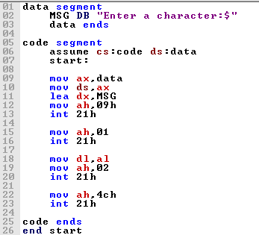

**Output:**

1. Interrupt 09H – Display string

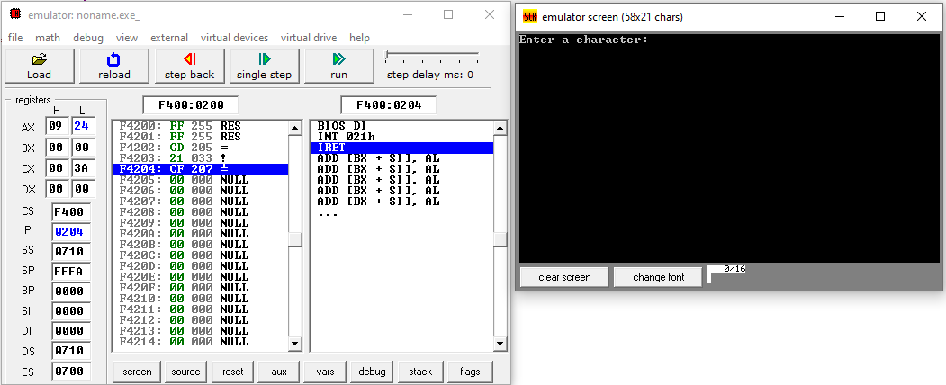

1. 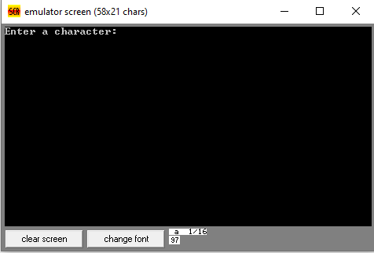Interrupt 01 – Accept input and display asci
2. Interrupt 02 – Display input

